Docker Task
Task Description
Install docker on EC2 and explore the docker commands (docker images, containers, volumes, network)

- Deployed a New Ec2 instance in AWS and named as test1 server.
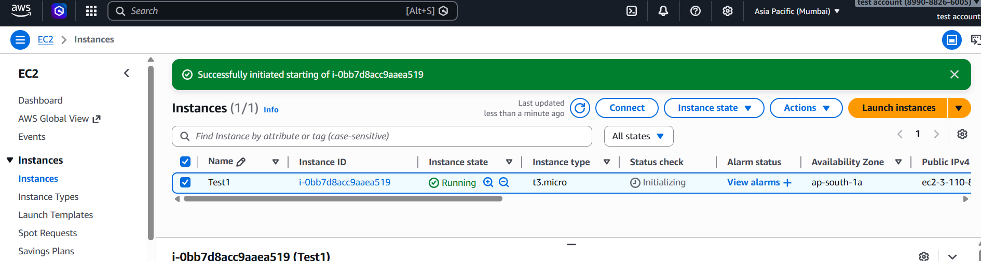
- Connected the server and installed the Docker and below screenshot shows the Docker version and the active status.
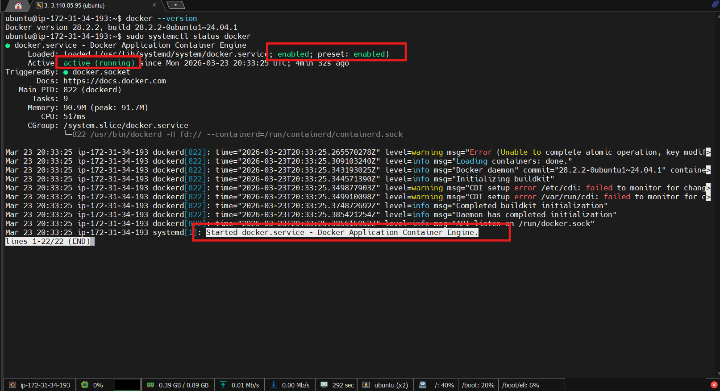
- Created few sample docker images.
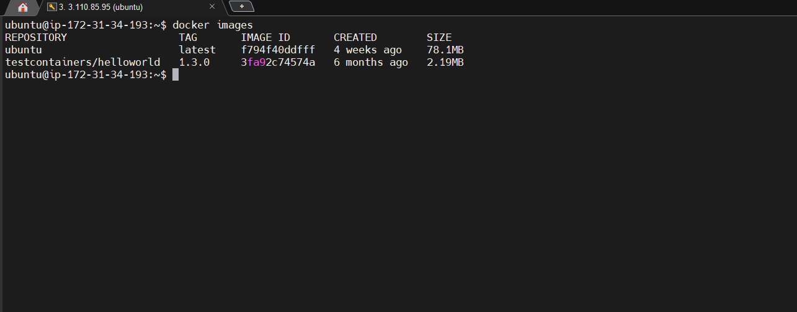
- Normal user profile cannot run the Docker image hence provided the permission to the existing profile.
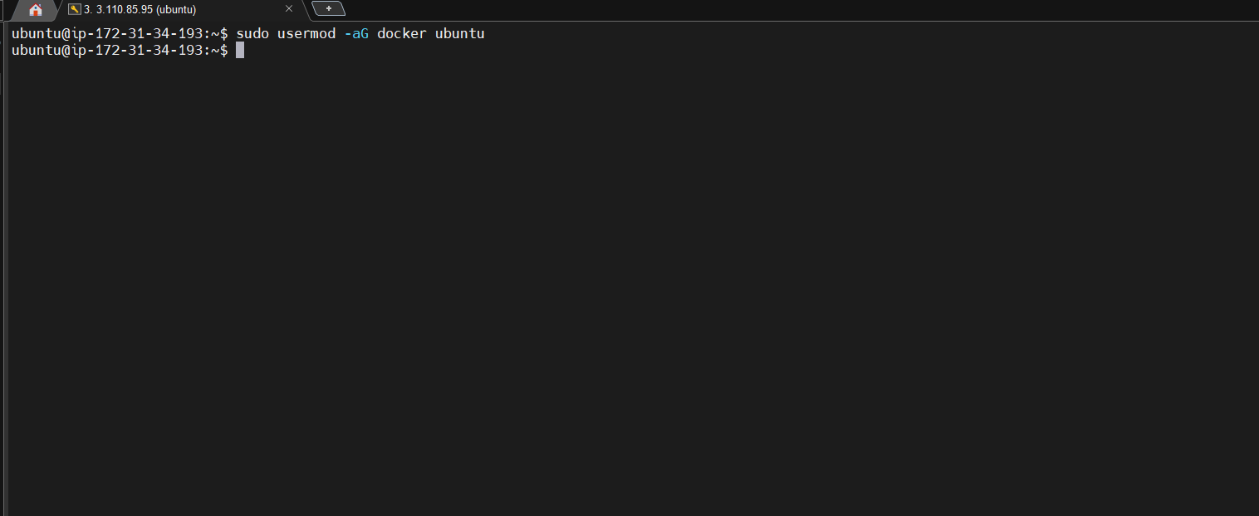
- Used the Docker pull command to so that used docker hub to get the latest image .
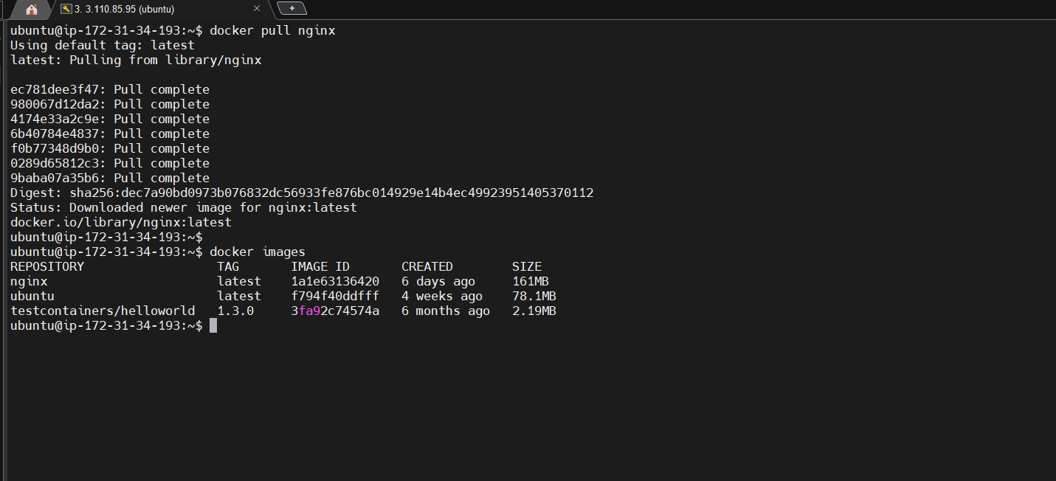
- Ran Docker container and was able to see the output In the Browser.
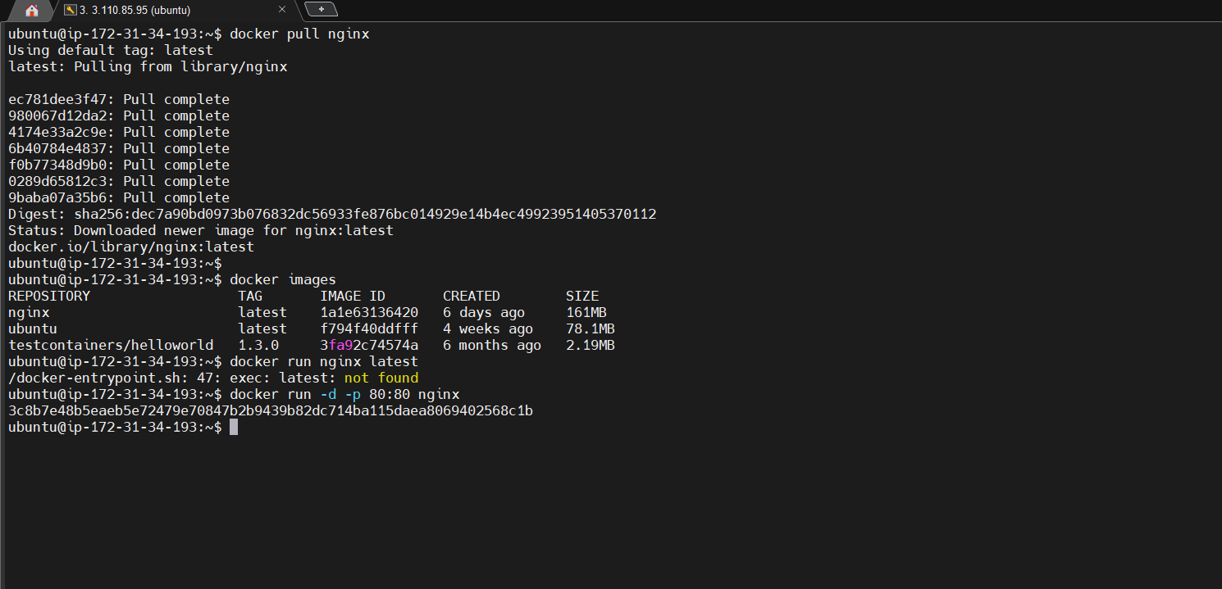
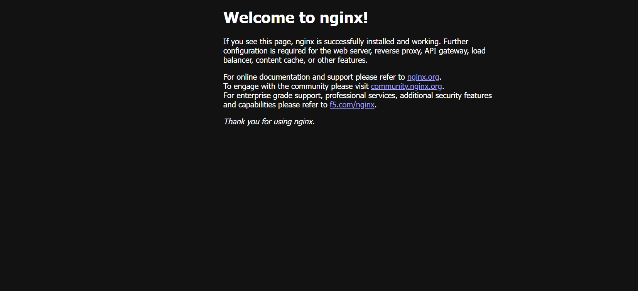
- Created a new docker volume and listed the volume.
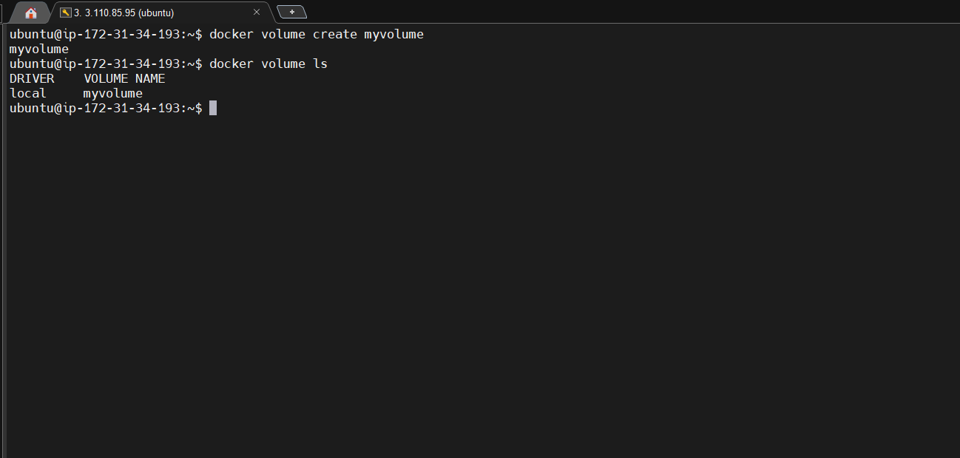
Ran container with Volume
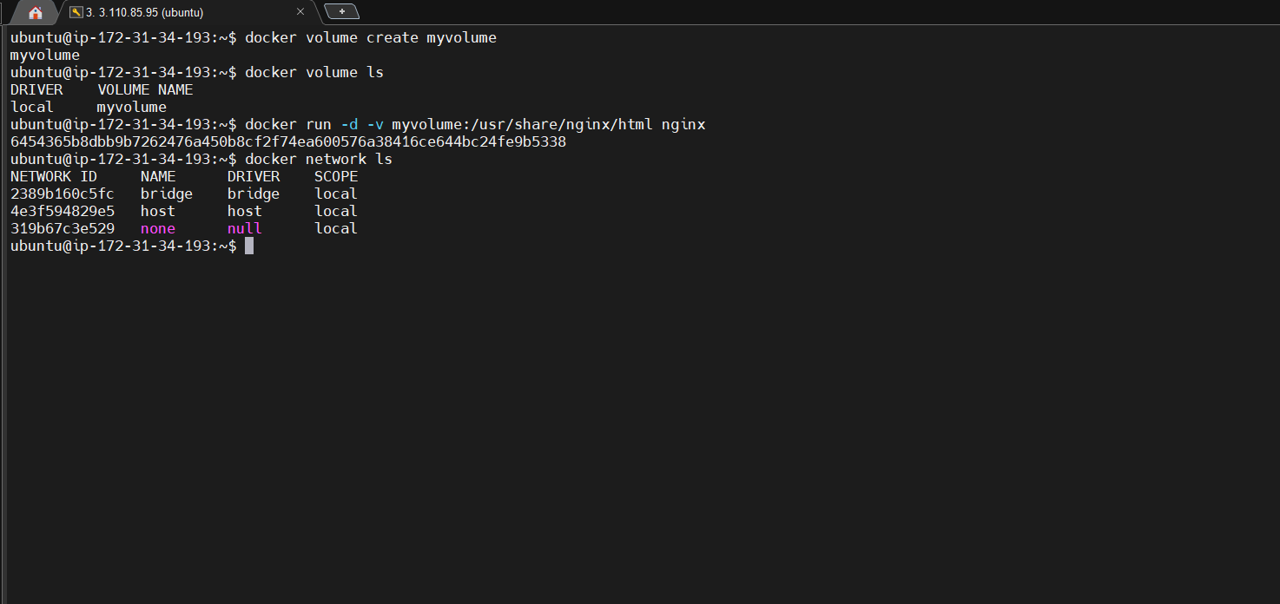
- Created a Docker Network and listed the created networks .
